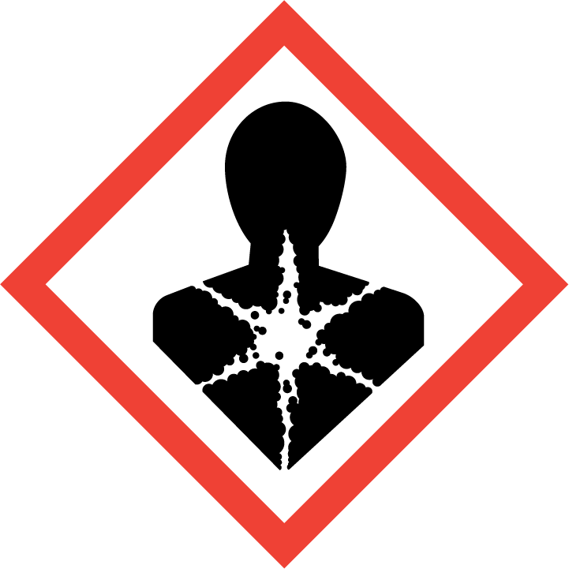
CAN SIGNIFFY ONE OR MORE OF THE FOLLOWING; DELETE AS APPLICABLE
RESPIRATORY SENSITISER/CARCINOGEN/ MUTAGEN/REPRODUCTIVE TOXIN/TARGET ORGAN TOXICITY/ASPIRATION HAZARD

